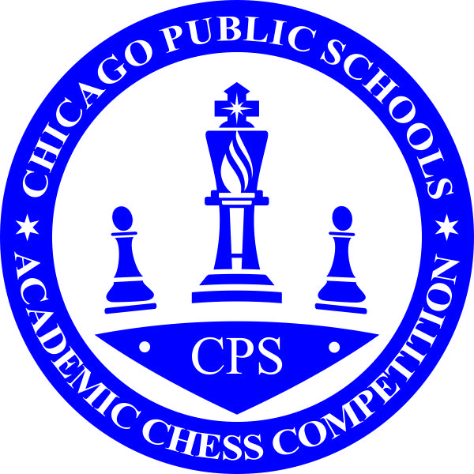

CHICAGO PUBLIC SCHOOLS
2017 - 2018 ACADEMIC CHESS COMPTITION

RULES AND REGULATIONS

- COVERAGE
These rules and regulations apply to all Chicago Public School students and schools participating in Academic chess competition.

- ACADEMIC CHESS COMPETITION
Academic chess competition is competition in which students from one or more CPS school(s) compete.

- ADMINISTRATIVE RESPONSIBILITY
    - Administrative responsibility for chess and Academic chess competition in Chicago Public Schools is under the Office of College & Career Success, who will designate a Chess Coordinator to oversee Academic chess competition.
    - Individual school’s Principal shall be ultimately responsible in all matters pertaining to Academic chess involving their school and students. The Principal of each member school shall designate an individual at the school who is responsible for all matters pertaining to the conduct of Academic chess competition for their school.

- STRUCTURE
    - Academic chess competition will be divided into 2 categories: Elementary/Middle School (Grades K-8), and High School (Grades 9-12).
    - Academic chess competition shall be conducted using the current edition of the U.S. CHESS FEDERATION OFFICIAL RULES OF CHESS and/or IHSA and any modifications or changes in competition rules as established by these rules and regulation
    - Team competition is based on 8-person and 5-person co-ed team format
    - Individual competition is based on individual matches. The top 4 players from the same school may be added together to determine team awards.
    - The chess season will consist of conditioning and practice, dual matches, Conference and City-wide competition, Conference Playoffs for Grades K-8, and City-wide Championship
    - Standard time control for tournaments and matches is G/25 [Game time per player: 25 minutes with 5 second delay] unless the coaches agree to or pre-announcement specifies other time control.
    - High School competition utilizes 8-person Varsity teams and 5-person Junior Varsity team
    - High Schools will have one city-wide conference with a Championship competition which should be held 2 weeks prior to the IHSA Finals.
    - Elementary/Middle School competition is divided into 4 divisions:
      - Lower Primary (Kindergarten to Grade 2)
      - Upper primary (Grade 4 and under)
      - Intermediate (Grade 6 and under)
      - Junior High (Grade 8 and under)
    - Elementary/Middle Schools will be divided into formal conferences.
      - Schools will be assigned to conferences by the chess coordinator.
      - Each conference will have a Conference Championship competition (playoff).
      - Winners of the Conference Playoffs will advance to the Championship competition.

- SEASON:
    - The Chess season will determined by the Chess Coordinator to include the dates, locations and format of the Conference Playoffs and CPS Championships.
    - Elementary and Middle Schools are required to compete in four (4) matches to qualify for their Conference Championships.
    - High Schools are required to compete in four (4) team matches to qualify for the Varsity Championships and two (2) matches for teams to qualify for the Junior Varsity Championships. (Note: 6 matches are required for the entry to the IHSA Series)
    - Elementary and Middle Schools conference advancement to the CPS Championship is limited to the top 3 teams & top 4 individuals who are not a part of team moving. Advancing teams are limited to five (5) players at the Championship.
    - A tournament is where five (5) or more school teams compete for three (3) or more rounds is the equivalent to two matches.
    - Dual and Internet matches count as one match.

- TEAM TOURNAMENT AND MATCH FORMAT
    - Teams should consist of 8 or 5 players during tournaments and matches; minimum of 7 or 4 players respectively.
    - One player may be named captain, and each player shall play only one game during a match.
    - Players must play on the same board throughout the tournament/match.
    - Substitutes may play different boards; however a substitute can only play any board once. If a substitute plays the same board twice, then that substitute can only play that board.
    - Tournaments and Matches will be played using weighted boards (board points).
    - Players shall play in rating/strength order. The highest rated/strongest player on the team must play board one, the second strongest player must play board two, etc. Players within 100 points of each out of order (switched). The Floor Chief or Chief TD may authorize board switches on a case by case basis.
    - If a team starts a tournament/match without a player, then the last board will be left empty and scored as a loss.
    - After the first round/match, should a player miss a round, substitutes can be used or the board left empty and scored as a loss. Substitutes can only play on the board they substituted on.
    - 8-player home team will play white on boards 1, 3, 6 and 8 and black boards 2, 4, 5 and 7. 5-player home team will play white on boards 1, 4, and 5 and black boards 2, 3.
    - Match Scoring:
      - 8-board match
Board | Win | Draw | Lost
1 | 12 | 6 | 0
2 | 11 | 5.5 | 0
3 | 10 | 5 | 0
4 | 9 | 4.5 | 0
5 | 8 | 4 | 0
6 | 7 | 3.5 | 0
7 | 6 | 3 | 0
8 | 5 | 2.5 | 0

      - 5-board match
Board | Win | Draw | Lost
1 | 8 | 4 | 0
2 | 7 | 3.5 | 0
3 | 6 | 3 | 0
4 | 5 | 2.5 | 0
5 | 4 | 2 | 0

    - Participants playing black will supply the equipment, therefore each school must provide chess boards, Staunton design chess sets, and digital chess time delay clocks for at least half of the individuals they have participating. By mutual agreement, one team may supply all of the equipment.
    - In cases of a team dropping out from competition before the third round/match has been played, all match scores against them shall be dropped
    - If team drops out after the third round/match, the remainder of its matches shall be scored as forfeits.
    - Any team playing an ineligible player shall forfeit the ineligible player’s board scores and forfeit any award achieved using the ineligible player’s score.
    - Players at competitions should wear apparel that would indicate a uniform that uniquely identifies that team; t-shirts, patches, etc.

- PLAYER ELIGIBILITY
- A player may only play for the school they attend
- During the conference Playoffs, players may play up (in a higher division) to be part of a team.
- Conference Playoff team rosters are frozen; players must play in the division they are listed in throughout the playoffs and Championship.
- Players must know the basic rules of chess and how the pieces move. A player who does not know these basics may be removed from the tournament/match by the Floor Chief or Chief TD.

- COACHES DUITES AND RESPONSIBILITIES
    - Coaches must participate in 4 team matches and their team must play in the Conference Playoff or High School Championship to qualify for the chess coach’s stipend.
    - Coaches are responsible for the control and conduct of their team members.
    - Coaches are responsible to arrange for the number of chaperones needed to properly supervise their team member.
    - Coaches or a representative from each school must be present at the beginning of a tournament/match and remain throughout the event.
    - Coaches are responsible for checking in their players at tournaments/matches.
    - Coaches are responsible for seeding their team in board order at team tournaments/matches.
    - Coaches are responsible to review and sign the team results sheets; coaches may delegate this responsibility to the Team Captain.
    - Once a match begins, coaches and players cannot communicate except by using authorized “COMMUNICATION CARDS”. The procedure is for the coach or player to fill out the card, hand it to a TD who will read the card and pass it on to the coach or player if valid. The coach or player will read the card, write their answer and hand the card back to the TD who will read the card and pass it on to the coach or player if valid.

- SPECTATORS
    - Spectators are not allowed in the playing area or within designated boundaries set by the Chief Tournament Director.
    - A spectator is anyone not currently playing a match (i.e. parent, coach, player whose game is finished)
    - Exceptions to this rule include:
      - Coaches at Team Tournaments.
      - Coaches and players at High School Tournaments.
      - Other person(s) authorized by the Chief Tournament Director.
      - The Floor Chief or Chief Tournament Director may designate boundaries, conditions or revoke any or all these exceptions if the presence of spectator(s) is deemed disturbing to players.

- CHESS NOTATION & CHESS TIMERS
    - Chess notation is required for all players, except in the K-2 division. Chess notation is necessary to adjudicate, reconstruct, and for player’s to study their games.
    - Chess notation may be written in long or short algebraic notation or descriptive form and must be in accordance with the most recently published edition of THE USCF OFFICIAL RULES OF CHESS.
    - If a player divisions decides not to notate, 10 minutes, or half the time remaining, (whichever is less) will be deducted from his/her time
    - Players who fail to keep notation shall lose the right to make claims for which notation would be required.
    - If a player has less than 5 minutes remaining on his/her timer, he/she may stop notating without penalty. Once this happens, the opponent may then also choose to stop notating, if he/she wishes to do so, even if the opponent has more than 5 minutes remaining on his/her own timer.
    - A notation sheet must, to be considered satisfactorily filled out, not have more than three consecutive missing or incomplete move pairs (a move pair being consecutive moves by each player).
    - Use of timers (when available) is required and is to be used in accordance with the most recently published edition of THE USCF OFFICIAL RULES OF CHESS.

- VIOLATIONS RULES & REGULATIONS
    - Penalties for violation of the regulations and THE USCF OFFICIAL RULES OF CHESS shall be imposed by the Tournament Directors.
    - Tournament Directors may impose penalties to include, but are not restricted to: Warning, forfeiture of games, forfeiture of team match play, or other such penalties as outlined in these Regulations, and/or the most recently published edition of USCF OFFICIAL RULES OF CHESS.
    - The Chief Tournament Director may also impose penalties to include denial of participation and expulsion of an individual or team.

- REQUEST FOR RULING, APPEAL PROCEDURE, AND QUESTIONS OF CONCERN
    - It is the player’s responsibility to make a REQUEST FOR RULING.
    - A player has the right to stop both clocks to ask a Tournament Director to rule upon a point of law, procedure, or conduct.
    - A player may appeal a ruling to the Floor Chief; the Floor Chief ruling cannot be appealed.
    - A coach, parent, or any third party may not request a ruling covering game play.
    - A player or coach may request a ruling covering pairings, possible errors in scoring, or a concern by completing a Question of Concern form. The procedure is for the coach or player to fill out the form and turn it into the designated person. The Floor Chief, Backroom Chief or Chief Tournament Director will write their ruling and the designated person will inform the coach or player of the answer.
    - A player or coach may appeal a ruling to the Chief Tournament Director; the Chief Tournament Director ruling cannot be appealed.
    - A challenge to a recorded score is limited to the following round.

- TIEBREAK SYSTEMS
    - Board Team tiebreak order:
      - IHSA
      - US Amateur
      - Performance Index
      - Game/Match Point
    - Individual/Team tiebreak order:
      - Modified Median
      - Solkoff
      - Cumulative
      - Opponents Cumulative

- SPORTSMANSHIP
    - Participant, coach, trainer or other attendant must not commit an unsportsmanlike act. This includes, but not limited to, acts or conduct such as:
- Disrespectfully addressing an official, coach, or participant or gesturing in such a manner as to indicate resentment.
- Using profane or inappropriate language or gestures.
- Baiting or taunting an opponent. Any form of taunting which is intended or designed to embarrass, ridicule or demean others under any circumstances, including on the on the basis of race, religion, gender or national origin is disapproved.

