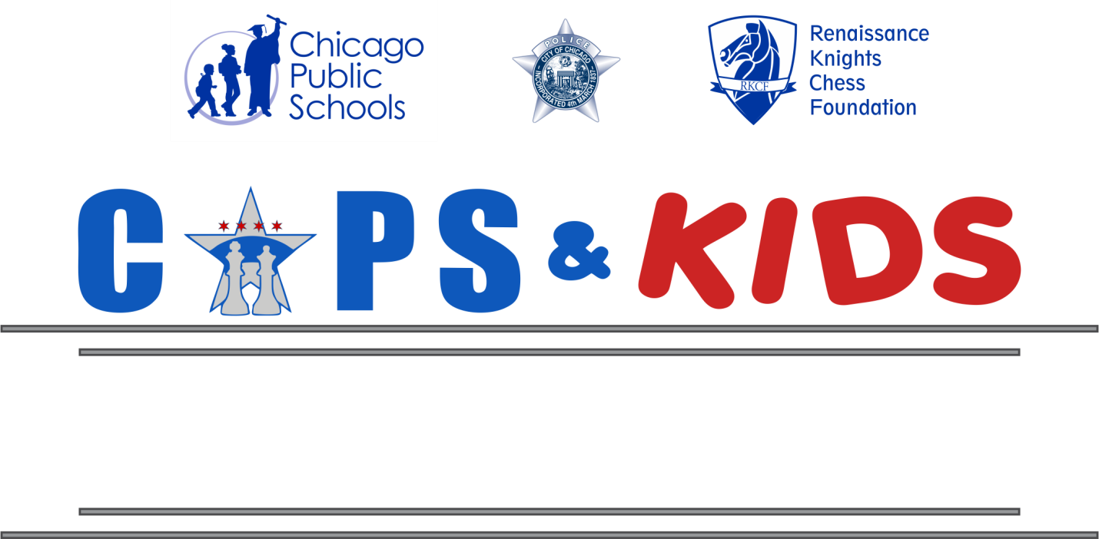

AFTER SCHOOL CHESS CLUB FOR
SCHOOL NAME
Mondays 3:15 – 4:15 pm Starting Sept 18, 2017
The Chicago Public Schools and Renaissance Knights Chess Foundation, in partnership with the Chicago Police Department, are excited to bring to your school the many educational benefits of learning chess. This unique program is intended to promote non-violence and increase positive relationships with youth and police officers while utilizing the game of chess as the vehicle for engagement. Local police officers will participate in the class and will serve as mentors and role models to the students.

The chess club will give students the opportunity to have fun while making it easy for them to learn play chess. Students will be taught the fundamentals of chess, its rules, how each piece moves, and will learn to apply chess tactics, strategies and problem solving that have been proven to transfer to academic, social and life skills.

Students will also have the opportunity to be a part of the school’s chess team and compete in tournaments throughout the school year. Tournaments include the Cops & Kids Chess Tournament, the Greater Chicago Championship, and the CPS Regional Playoffs & Championships.
TFree chess classes for Goethe students in grades 3-5!
TFree chess classes for Goethe students in grades 3-5!

For more information or to register for the club
contact your school’s chess coordinator
Name email@cps.edu

